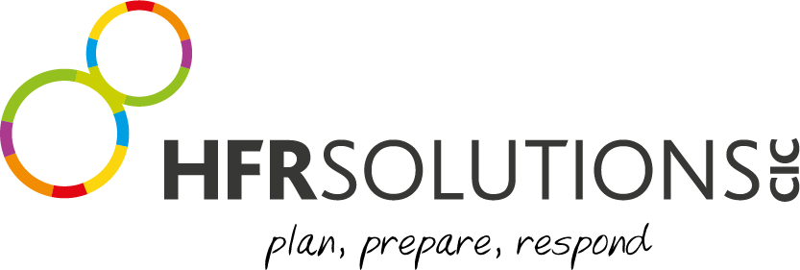

Community Fund Application Form

YOUR ORGANISATION
1 | Organisation name
2. | Main contact name and address, phone and email for this application
3. | Organisation registered address, phone and email (if different from above)
4. | Does your organisation have a website? If so, what is it?
5. | Is your group a Charity or Non-profit making organisation? (If you are a charity, company or CIC please provide registration numbers)
10. | What are the main aims and activities of your organisation?
11. | What is the name of your project?
12. | When will your project start and end?
13. | Who will benefit from the project and what is their need?

COMMUNITY FUND APPLICATION PROCESS

Guidance

Criteria for applications:

Must reside within the Humber Region – Hull, East Riding of Yorkshire, NE Lincolnshire, North Lincolnshire

The committee meet monthly to consider applications.

If a donation is made, you will be required to evidence how the money has been spent.

Deadline for applications are the end of each month, to be considered at the following month’s meeting.

Decisions on applications will be issued by the end of the following month.

If you would like to apply, please send your application to community@hfrsolutions.co.uk

SOLUTIONS PERSONNEL USE ONLY
Application Received Date:
Application Approved: | YES NO
Amount Approved:

Approval Date:
Project Reference Number:
Project Lead
Approved by:

